Database Filtering & Logical Queries
Ques1. Find students with marks greater than 80?
Query:- db.students.find({marks:{$gt:80}})
Output:-
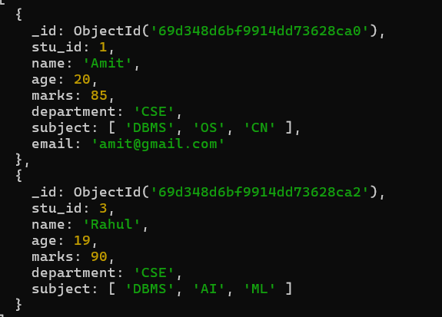
Ques2. Find students aged less than or equal to 20.
Query:- db.students.find({age:{$lte:20}})
Output:-
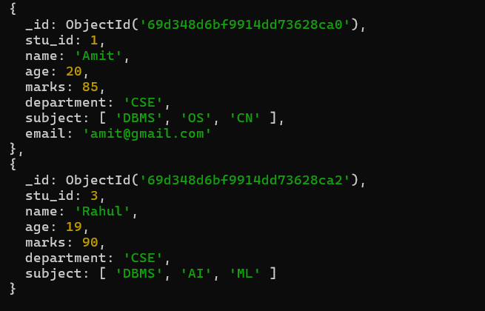
Ques3. Find students with marks between 70 and 85.
Query:- db.students.find({marks:{$gte:70,$lte:85}})
Output:-
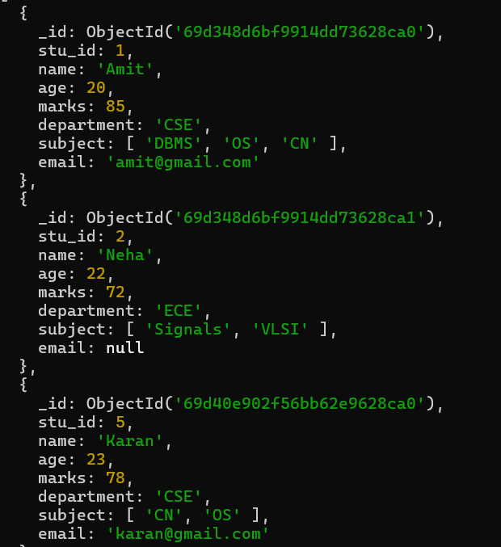

Ques4. Find students not belonging to CSE department.
Query:- db.students.find({department:{$ne:"CSE"}})
Output:-
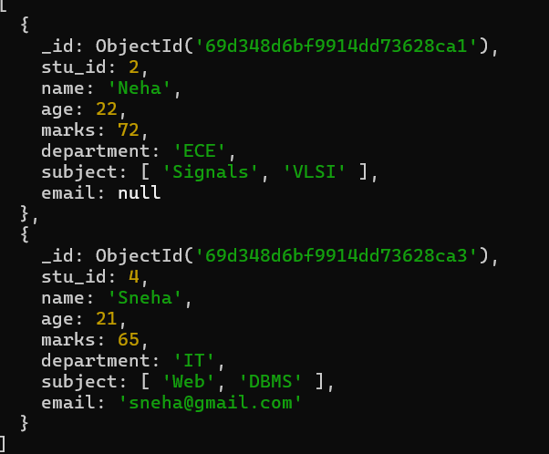
Ques5. Find students whose age is exactly 21.
Query:- db.students.find({age:21})
Output:-
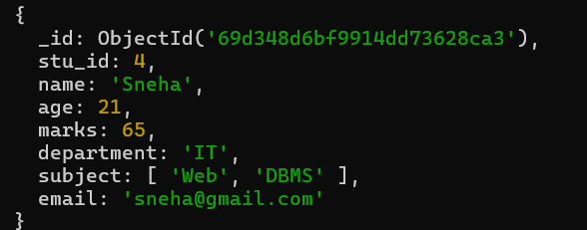
Ques6. Find students with marks less than 75.
Query:- db.students.find({marks:{$lt:75}})
Output:-
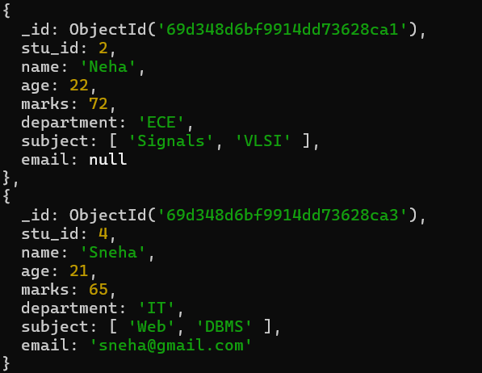
Ques7. Find students whose department is either CSE or IT.
Query:- db.students.find({department:{$in:["CSE","IT"]}})
Output:-
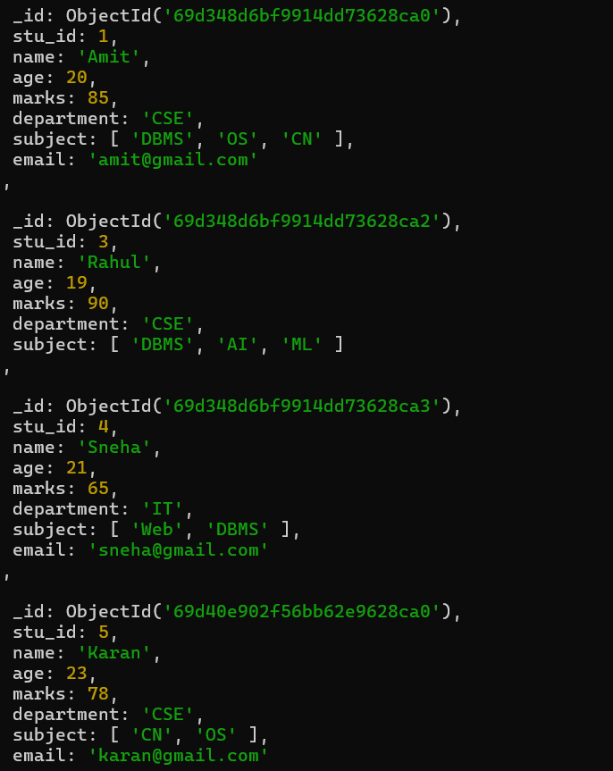
Ques8. Find CSE students with marks above 80.
Query:- db.students.find({department:"CSE",marks:{$gt:80}})
Output:-
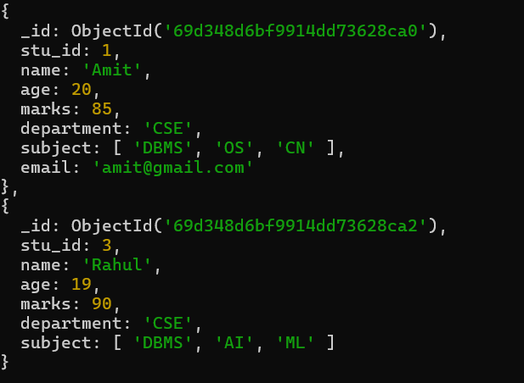
Ques9. Find students who are in CSE or have marks above 85.
Query:- db.students.find({$or:[{department:"CSE"},{marks:{$gt:85}}]})
Output:-
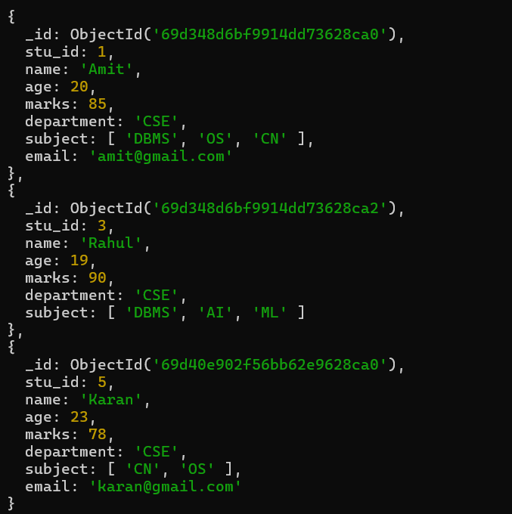
Ques10. Find students who are NOT in IT department.
Query:- db.students.find({department:{$ne:"IT"}})
Output:-
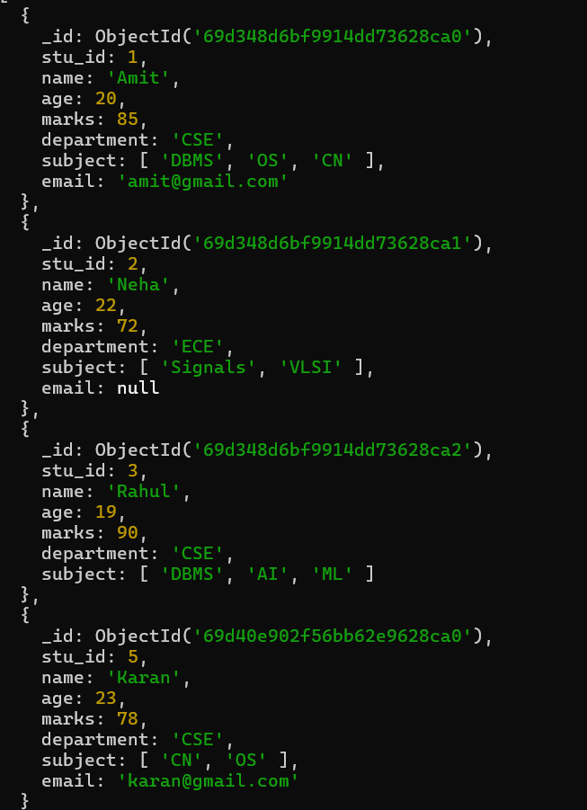
Ques11. Find students with marks not between 70 and 85.
Query:- db.students.find({marks:{$not:{$gte:70,$lte:85}}})
Output:-
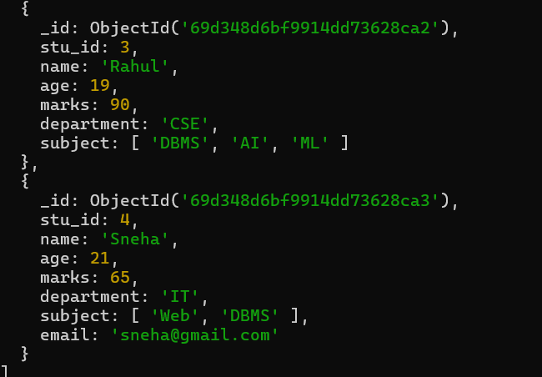
Ques12. Find students aged above 20 and not in ECE.
Query:- db.students.find({age:{$gt:20},department:{$ne:"ECE"}})
Output:-
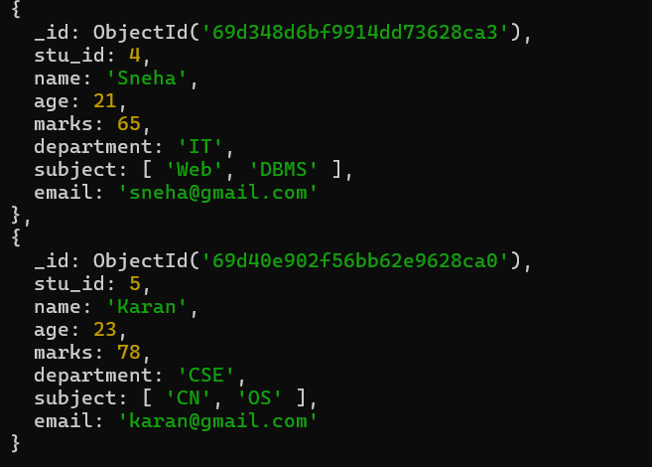
Ques13. Find students who are either IT students or have marks less than 70.
Query:- db.students.find({$or:[{department:"IT"},{marks:{$lt:70}}]})
Output:-
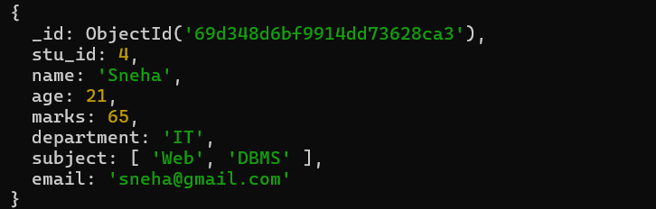
Ques14. Find students who are not CSE and not IT.
Query:- db.students.find({department:{$nin:["CSE","IT"]}})
Output:-
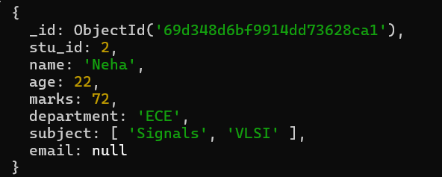
Ques15. Find students who have an email field.
Query:- db.students.find({email:{$exists:true}})
Output:-
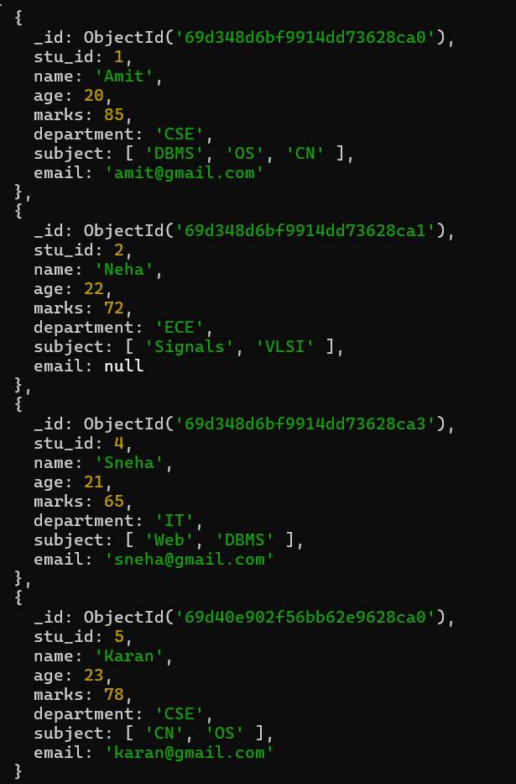
Ques16. Find students who do not have an email field.
Query:- db.students.find({email:{$exists:false}})
Output:-
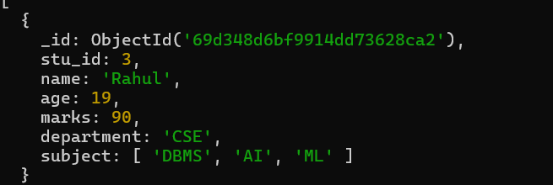
Ques17. Find students whose email value is null.
Query:- db.students.find({email:{$type:"null"}})
Output:-
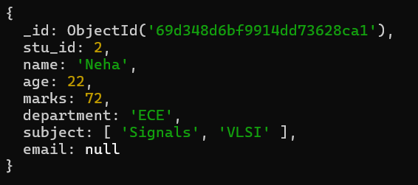
Ques18. Find students whose marks field is of type integer.
Query:- db.students.find({marks:{$type:"int"}})
Output:-
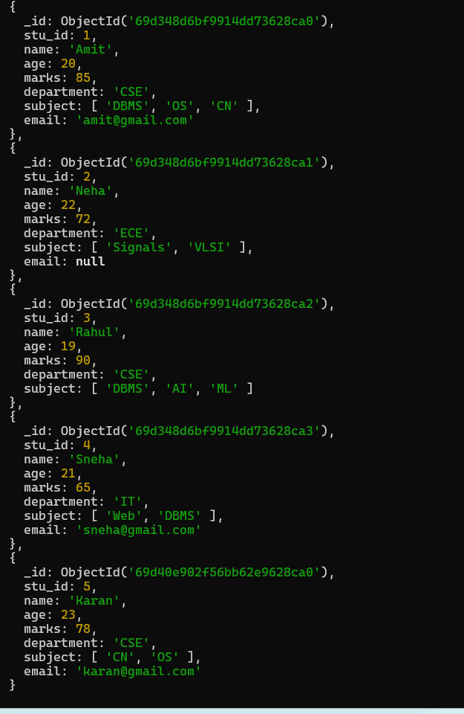
Ques19. Find students who have subjects’ field.
Query:- db.students.find({subject:{$exists:true}})
Output:-

Ques20. Find students whose age field is missing.
Query:- db.students.find({age:{$exists:false}})
Output:-

Ques21. Find students where marks modulo 5 equals 0.
Query:- db.students.find({marks:{$mod:[5,0]}})
Output:-
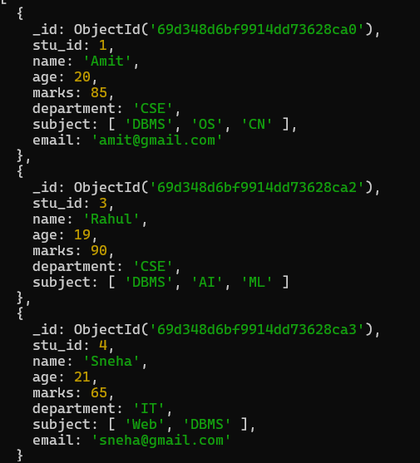
Ques22. Find students whose name starts with letter “A”.
Query:- db.students.find({name:/^A/})
Output:-
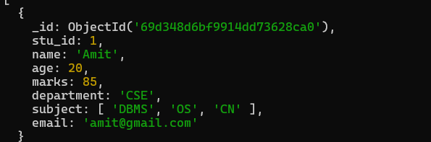
Ques23. Find students whose email ends with gmail.com.
Query:- db.students.find({email:/@gmail\.com$/})
Output:-
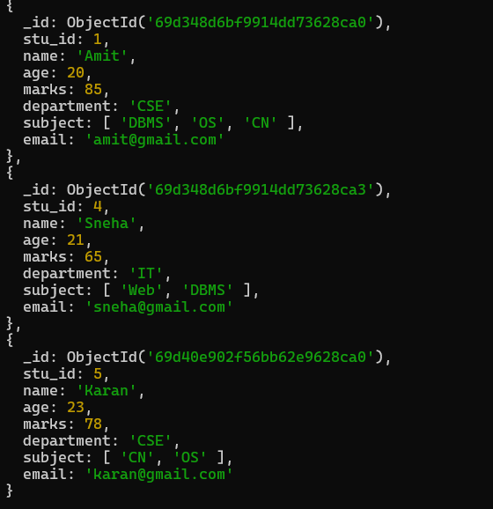
Ques24. Find students who have more than 2 subjects.
Query:- db.students.find({"subject.2":{$exists:true}})
Output:-
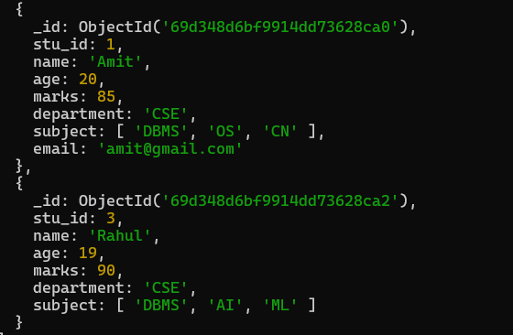
Ques25. Find students whose marks are greater than their age × 3
Query:- db.students.find({$expr:{$gt:["marks",{$multiply:["$age",3]}]}})
Output:-


